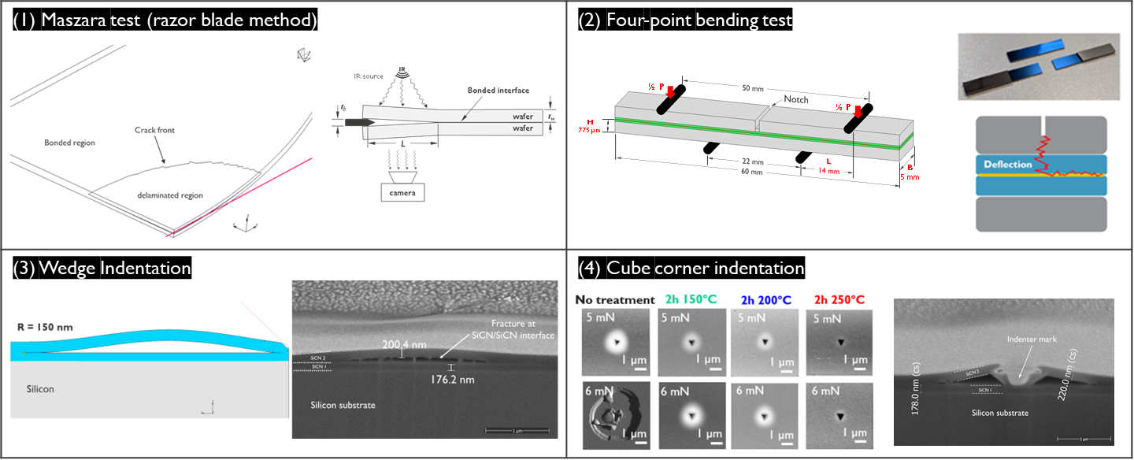

Multiple Testing Techniques Needed to Assess Wafer-to-Wafer Adhesion: Wafer-to-wafer hybrid bonding enables the integration of heterogeneous wafers with different functionalities and materials, and also enables high interconnection densities. However, hybrid bonding requires a dielectric layer with bonding energy high enough to withstand aggressive processing steps such as grinding, dicing and packaging. Characterizing the bonding strength between the wafers is vital but challenging. It requires reliable and accurate methods that can provide relevant information for optimizing the bonding process and ensuring the reliability of the devices.
IMEC researchers will describe several complementary techniques they used to assess the bonding strength of wafers with silicon carbon nitride (SiCN) as the primary bonding surface. The methods were: a Maszara test, four-point bending, and nanoindentation-based techniques (using wedge and cube corner indenter tips). Because these tests yield similar trends when used in the same interface, the researchers say using them together enables results to be cross-checked for accuracy. For example, in their test devices, in all cases it was observed that the adhesion energy of SiCN/SiCN interfaces increases rapidly at post-bond anneal temperatures of ~200°C, and reaches its maximum at 250°C.

The images above show:
- 3D FEM simulation of the razor blade test and a schematic diagram showing its principle.
- Schematic setup for the four-point bending test and a representative tested sample.
- Finite element model of the wedge indentation and FIB cross-section after testing
- Typical indentation marks after cube corner indentation test and FIB cross-section showing the fracture at the dielectric bonding interface.

(Paper 19.5, “Methodologies for Characterization of W2W Bonding Strength,” M. Gonzalez et al, IMEC)

